-> What is standalone application ?

- Specific to one system

- Ex : IDE, Notepad, Calc etc..

-> What is Web application ?

- These apps will run over internat

- Multiple users can access at a time

- Ex : Gmail, Facebook, IRCTC etc..

-> What is Distributed application ?

- B 2 B communication

- To re-use business services of one app in another app

- Ex : Passport-Aadhar, MakeMytrip-yatra etc..

-> To develop Distributed applications we will use distributed technologies.

CORBA

RMI

EJB

Webservices and

RESTful Services

-> CORBA stands for 'Common Object Request Broker Architecture'. In CORBA we have to write IDL (Interface Definition Language) and we have to convert into language specific object then we should write business logic to expose for other applications.

-> As CORBA is forcing to start with IDL language for development it got vanished from market very quickly.

-> To overcome the problems of CORBA, RMI came into picture.

-> RMI stands for Remote Method Invocation.

-> RMI not supported for Connection Pool, Tx, Audit, Logging, Security etc so people felt un-happy with RMI also.

-> As an alternate for RMI, EJB came into Market.

-> EJB stands for Enterprise Java Beanas. This is one of the powerful Technology provided by Sun Microsystem.

-> EJB is the first technology which introduced Container and Container Managed Objects.

-> If we develop distributed application using EJB, only java applications can communicated.

What is webservice?

Webservice is a technology used in distributed Systems to support interoperability.

Interoperability:- Irrespective of Language and Domain. Communicating with each other.

WS-I team has been created to work for interoperability. Webservices Interoperability.

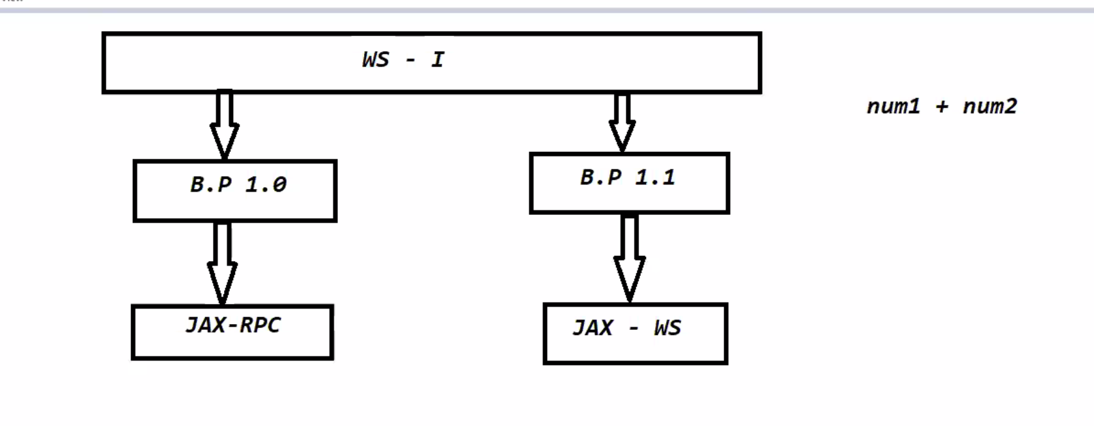

If we develop a webservice by using RPC and JAX-WS is called SOAP based web services. JAX-RPC Java API for XML. ---JAVA API for XML Representational Procedure

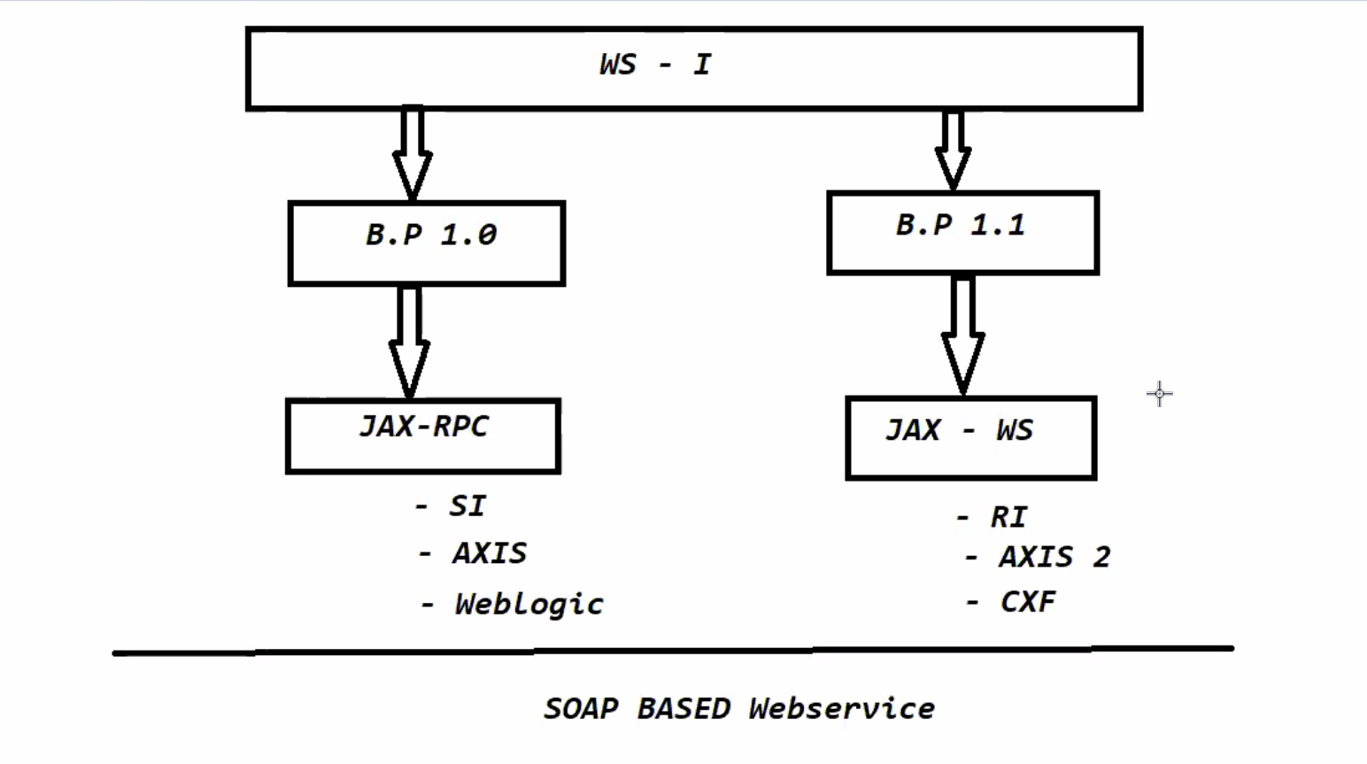

By using java we can develop SOAP Webservices in two ways

1. JAX-RPC API
2. JAX-WS API

**09-03-2021**

**Web Services Architecture:-**

Provider Application:- The application which is providing business services to another applications is called as Provider.

Consumer:- The application which is accessing business Services from another Applications is called a Consumer.

WSDL:- WSDL stands for Web Services Description Language. It contains provider details of the Provider. It is an XML. WSDL is a contract between the Provider and Consumer.

SOAP:- Simple Object Access Provider. SOAP acts as Payload carrier between Consumer and Provider.

UDDI:- UDDI is a registry where WSDL files will be stored currently it is outdated. UDDI stands for Universal Description Discovery and Integration

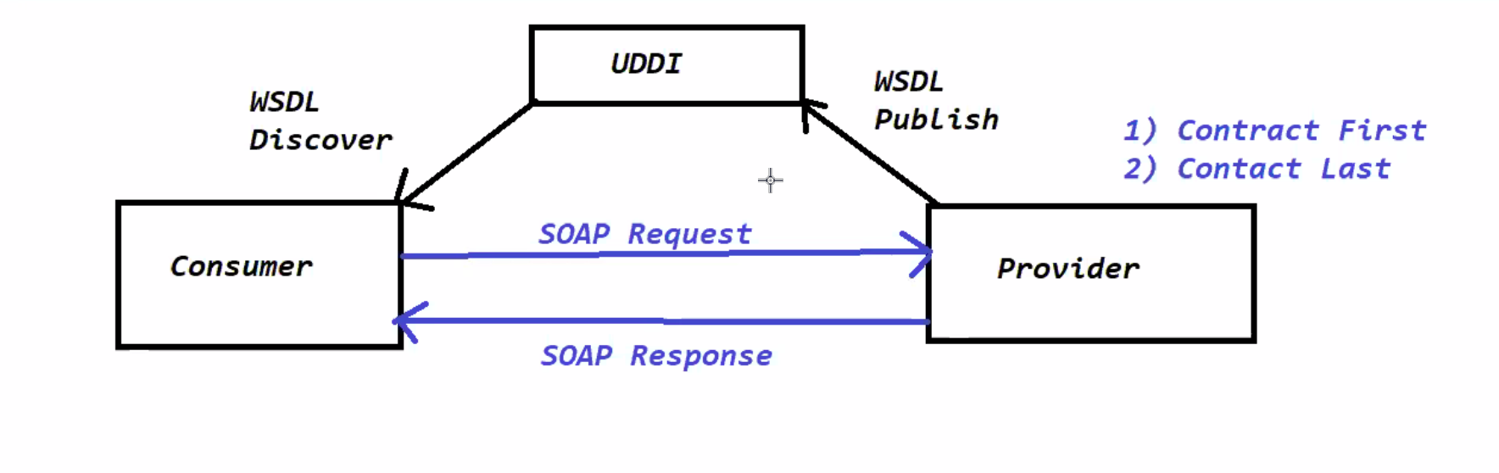

Provider will be Created in two ways

1. Contract first Approach
2. Contract Last Approach

Approach the Provider first and it will create Services and give WSDL Publish. And Consumer will approach the WSDL Discover.

Yatra is developed by using .net and IRCTC is developed by using java. They are communicating by using SOAP.

**10-03-2021**

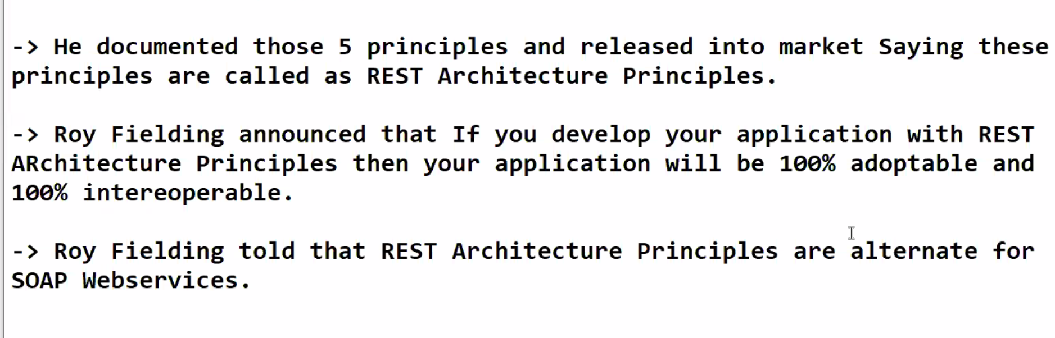

1. [Uniform interface](https://restfulapi.net/rest-architectural-constraints/#uniform-interface)
2. [Client–server](https://restfulapi.net/rest-architectural-constraints/#client-server)
3. [Stateless](https://restfulapi.net/rest-architectural-constraints/#stateless)
4. [Cacheable](https://restfulapi.net/rest-architectural-constraints/#cacheable)
5. [Layered system](https://restfulapi.net/rest-architectural-constraints/#layered-system)
6. Adoptobility and 100% Interoperable is not there with SOAP.

Roy Fielding identified 5 principles are called as REST Architecture Principles.

If we use those 5 principles our application is 100% adoptable and 100% interoperable. It is an alternate for SOAP Webservices. Google is the first company which adopts the RESTful Principles.

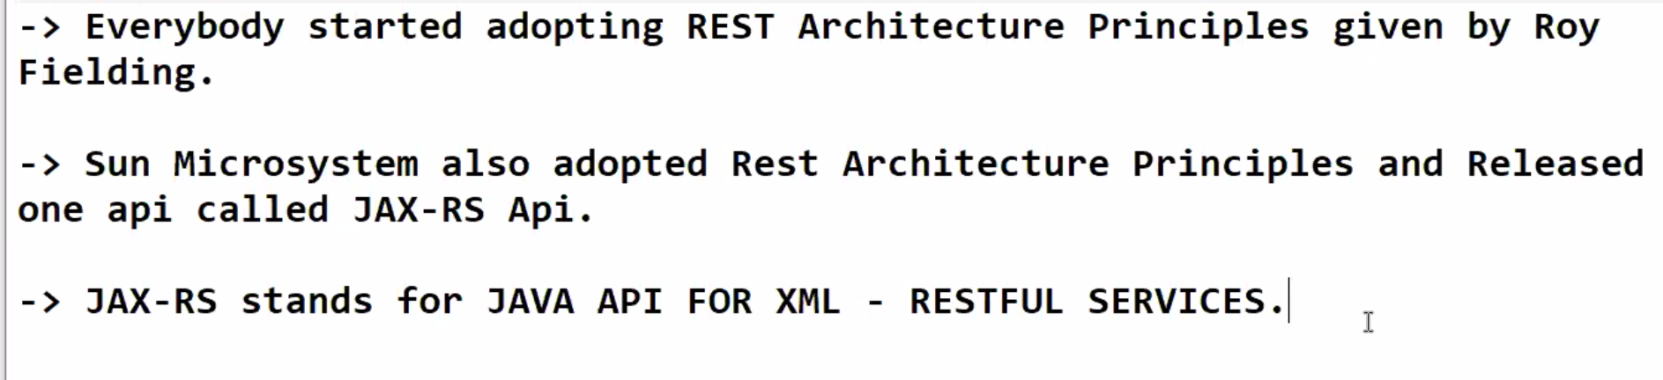

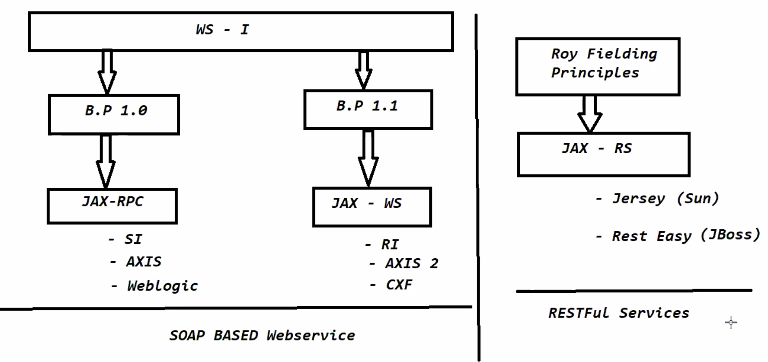

**11-03-2021**

**Rest Architecture:-**

In Restful Services Architecture we have 2 actors

1. Resource
2. Client

Resource will be available in one system and Client will be available in another System.

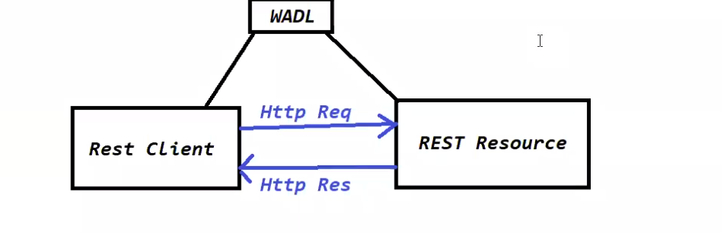

WADL provides the information of Resource

WADL-Web Application Description Language. We Describe the Rest API by using Swagger UI. WADL is out dated now we use Swagger.

**15-03-2021**

Two ways to build Restful Services.

1. Sun Micro Systems used Roy Fielding Principles and develop JAX-RS

--Jersey

--Rest Easy

2. By using Spring web mvc API

We can build Web Applications and Distributed applications also by using Spring Web MVC Module.

**Important Annotations**

**@RestController:-** To Represent the java class as a Rest Resource

**@RequestMapping**:- To bind class/ method to a URL Pattern.

**@GetMapping:-** To bind rest resource class method to HTTP GET Request

**@PostMapping**:- To bind the rest resource class method to HTTP POST Request

**@PutMapping:-** To bind the rest resource class methods to HTTP PUT Request, idempotent

**@DeleteMapping:-** To bind the rest resource class method to HTTP Delete Request

**@RequestParam:-** To read query Parameters from URL. Key value pair will be there

www.sattiIT/?name=spring

**@PathVariable:-** To read the Path parameters from URL. No Key value pairs

www.sattiIT/spring

**@RequestBody:-** To read the data from HTTP Request Body

**@ReseponseBody:-** To Write the Data to HTTP Response Body

To create Web application using Spring Boot we have to select the

**Spring-boot-starter-web**

**Spring-boot-starter-web** dependency will provide the below functionalities

1. Spring MVC support
2. Web App support
3. Rest Application support
4. Embedded server support

By default we will get Tomcat as an embedded server with default port number as 8080.

We can change the embedded server port number using application.properties file

Server.port=8080

**16-Mar-2021**

Whenever we use Restful web service we have to use single identification .Otherwise it will be confused.

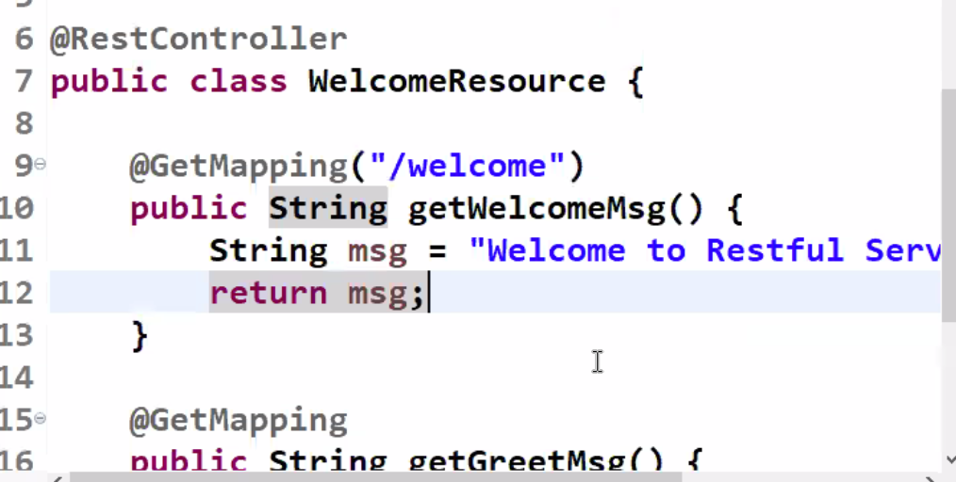

Method level URL is optional.

**17-Mar-2021**

Rest Controller bind to HTTP Protocol

We have several methods

@GetMapping

@PostMapping

@PutMapping

@DeleteMapping

If we have more than one method binded to same HttpRequest we should have separate

**JSON**:- Java Script Object Notation

JSON is an universal format to represent the data

Its is key value pair

It is interoperability.

JSON is light weight.

It is widely used to transfer the data from one application to another application.

Syntax:-

Data ={

“Name”:”sattibabu”

“Age:” : 31

}

**18-Mar-2021**

**Converting Json data into Object:- Jackson API to work with JSON data.**

Yesterday's session : JSON

---------------------------

-> JSON stands for java script object notation

-> JSON is intereoperable

-> JSON is light weight

-> Using Jackson api we can perform below operations

java obj -----------> json data

json data --------------> java obj

ObjectMapper mapper = new ObjectMapper();

//converting java obj to json

String json = mapper.writeValueAsString(Object obj);

//converting json data to java obj

Object obj = mapper.readValue(new File(String file), Class Type);

----------------------------------------------------------------------------------

package in.ashokit.domain;

import com.fasterxml.jackson.annotation.JsonInclude;

import com.fasterxml.jackson.annotation.JsonInclude.Include;

import com.fasterxml.jackson.annotation.JsonProperty;

import com.fasterxml.jackson.annotation.JsonPropertyOrder;

@JsonInclude(value = Include.NON_NULL)

@JsonPropertyOrder(value = { "sid", "sname", "sage", "address" })

public class Student {

@JsonProperty("sid")

private Integer studentId;

@JsonProperty("sname")

private String studentName;

@JsonProperty("sage")

private Integer studentAge;

private Address address;

public Integer getStudentId() {

return studentId;

}

public void setStudentId(Integer studentId) {

this.studentId = studentId;

}

public String getStudentName() {

return studentName;

}

public void setStudentName(String studentName) {

this.studentName = studentName;

}

public Integer getStudentAge() {

return studentAge;

}

public void setStudentAge(Integer studentAge) {

this.studentAge = studentAge;

}

public Address getAddress() {

return address;

}

public void setAddress(Address address) {

this.address = address;

}

@Override

public String toString() {

return "Student [studentId=" + studentId + ", studentName=" + studentName + ", studentAge=" + studentAge

+ ", address=" + address + "]";

}

}

----------------------------------------------------------------------------------package in.ashokit.domain;

public class Address {

private String city;

private String state;

private String country;

public Address() {

}

public Address(String city, String state, String country) {

super();

this.city = city;

this.state = state;

this.country = country;

}

public String getCity() {

return city;

}

public void setCity(String city) {

this.city = city;

}

public String getState() {

return state;

}

public void setState(String state) {

this.state = state;

}

public String getCountry() {

return country;

}

public void setCountry(String country) {

this.country = country;

}

@Override

public String toString() {

return "Address [city=" + city + ", state=" + state + ", country=" + country + "]";

}

}

---------------------------------------------------------------------------------

package in.ashokit.converters;

import java.util.ArrayList;

import java.util.List;

import com.fasterxml.jackson.databind.ObjectMapper;

import in.ashokit.domain.Address;

import in.ashokit.domain.Student;

public class JsonSerializer {

public static void main(String[] args) throws Exception {

/*

* Student s1 = new Student(); s1.setStudentId(101); s1.setStudentName("Ashok");

* s1.setStudentAge(25);

*

* // jackson api logic (converting java obj to json data) ObjectMapper mapper =

* new ObjectMapper(); String jsonString = mapper.writeValueAsString(s1);

* System.out.println(jsonString);

*/

Student s1 = new Student();

s1.setStudentId(101);

s1.setStudentName("Ashok");

s1.setStudentAge(25);

s1.setAddress(new Address("Hyd", "TG", "India"));

Student s2 = new Student();

s2.setStudentId(201);

s2.setStudentName("John");

s2.setStudentAge(34);

s2.setAddress(new Address("Vegas", "New York", "USA"));

List<Student> students = new ArrayList<Student>();

students.add(s1);

students.add(s2);

// jackson api logic (converting java obj to json data)

ObjectMapper mapper = new ObjectMapper();

String jsonString = mapper.writeValueAsString(students);

System.out.println(jsonString);

}

}

----------------------------------------------------------------------------------

package in.ashokit.converters;

import java.io.File;

import java.util.List;

import com.fasterxml.jackson.core.type.TypeReference;

import com.fasterxml.jackson.databind.ObjectMapper;

import in.ashokit.domain.Student;

public class JsonDeserializer {

public static void main(String[] args) throws Exception {

// Converting JSON data to java object

ObjectMapper mapper = new ObjectMapper();

/*Student obj = mapper.readValue(new File("student.json"), Student.class);

* System.out.println(obj);

*/

List<Student> students = mapper.readValue(new File("student.json"),

new TypeReference<List<Student>>() {});

students.forEach(student -> {

System.out.println(student);

});

}

}

---------------------------------------------------------------------------------

**19-Mar-2021**

Work with XML data.

XML stands for extensible Markup Language.

XML represents the data in tags format.

Initial version of XML is 1.0 and current version is also 1.0

XML file will start with prolog(Processing Instruction)

<?xml version=”1.0” encoding=”UTF=8.0”>

Sample XML file

<?XML version =”1.0” encoding=”UTF=8.0”>

<person>

<id>101</id>

<name>Satti babu</name>

</person>

**22-Mar-2021**

**XML vs JSON:-**

Xml represents in tags format

Json represents data in key-value pair.

Xml contains more metadata than actual data

<id>101</id>

Json contains less metadata

Id:101

XML is heavy-weight

JSON is light-weight

Note:- As JSON is having more advantages people are using widely in distributed networks to exchange the data.

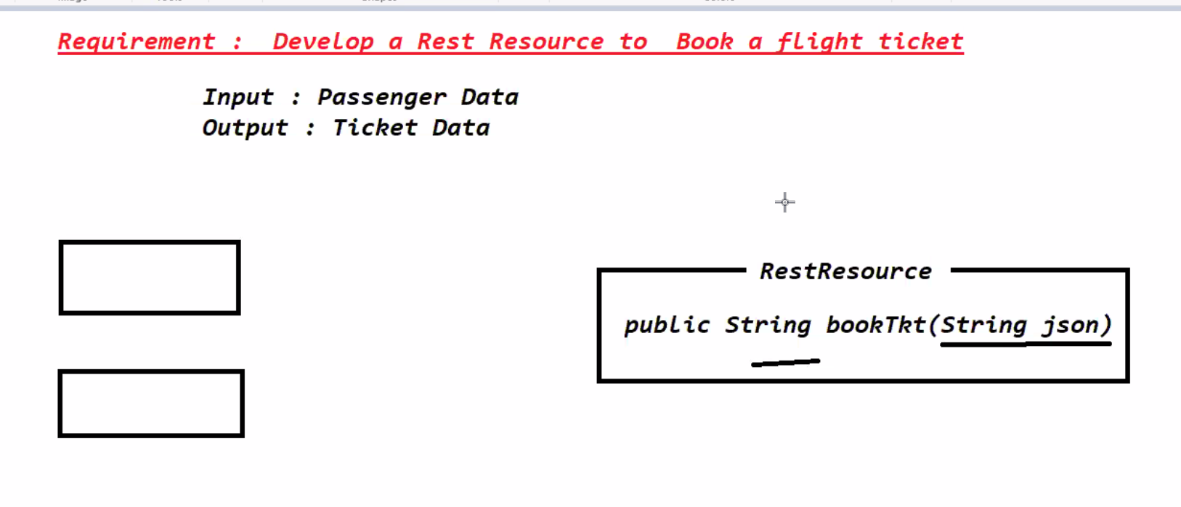

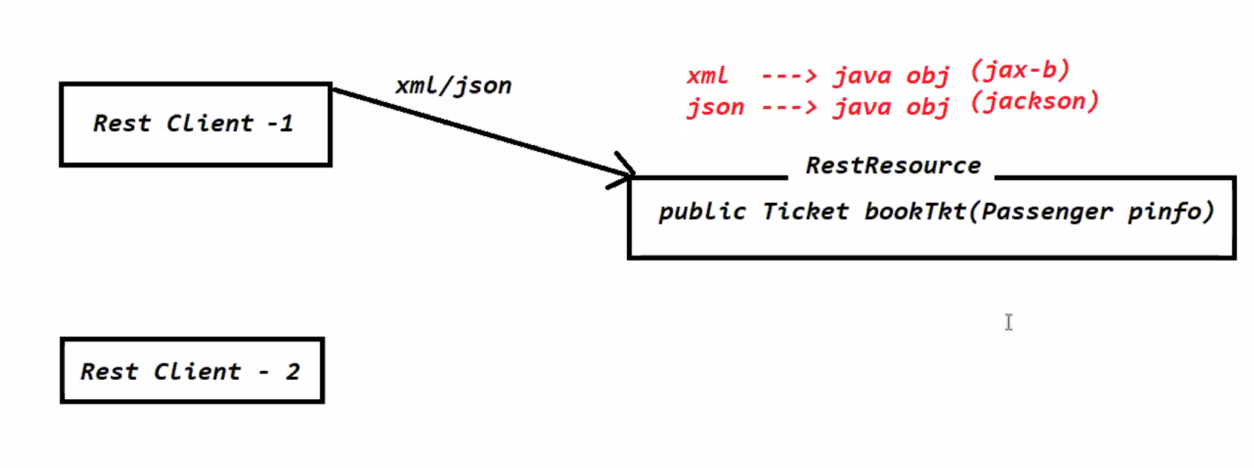

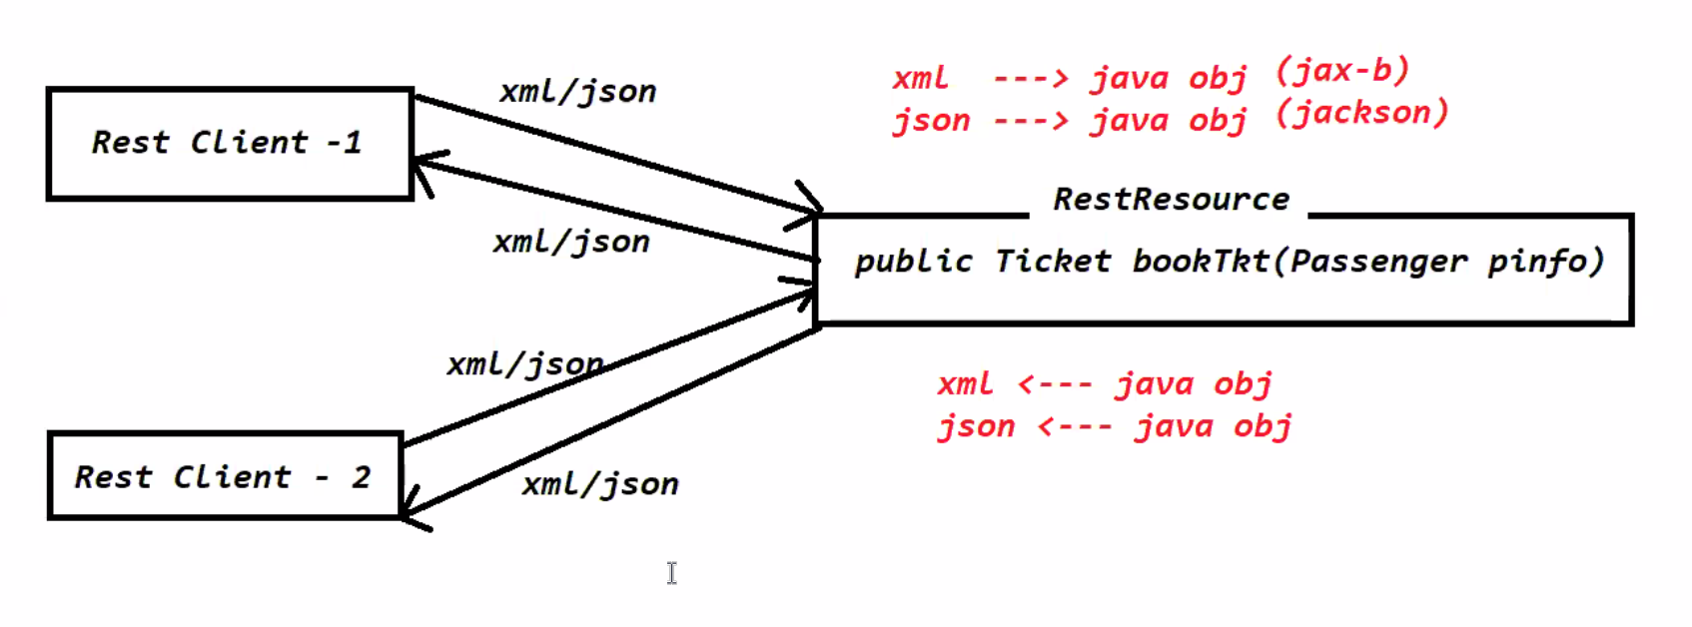

**Message converter** will be used in the Web MVC to convert the xml/json into java object and java object into xml/json Data.

Client should tell the response data format using **Accept** Header.

Request data format using **content-typ**e header

**23-Mar-2021**

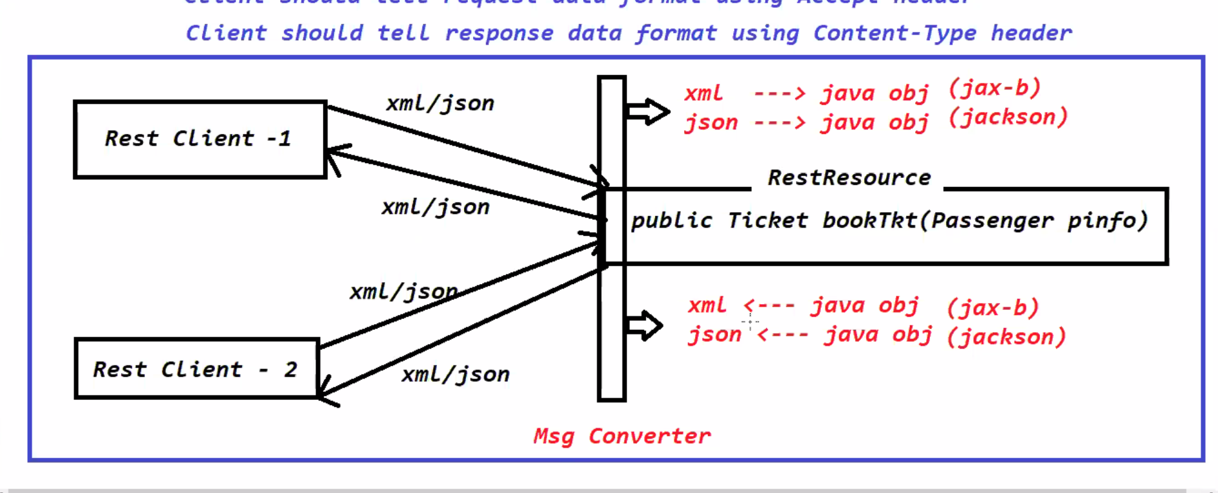

**Basics**

1. Distributed Applications
2. Distributed Technologies
3. What is Interoperability
4. CORBA
5. RMI
6. EJB
7. Webservice Evoluation
8. B.P 1.0 and B.P 1.1
9. SOAP Web services
10. SOAP Architecture
11. SOAP Drawbacks
12. REST Introduction
13. Rest Principles
14. Rest Architecture
15. First Restful Service App using Development using Spring Boot
16. POSTMAN
17. JSON & Jackson
18. XML & Jax-B
19. Accept and Content-type

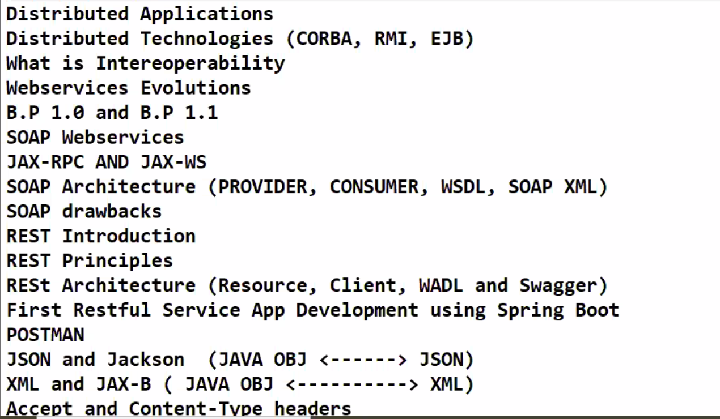

Jax-p—jax- parser It will read the data character by character where as Jax-B will represent the data in Object format.

**24-Mar-2021**

Accept Header:- It represents in which format client is accepting the response

Content-Type:- It represents in which format client is sending data. Based on Accept and Content-Type Message convertor will be convert Object -Json/XML and json/Object.

**Produces** attribute represents in which format that method can produce output Data.

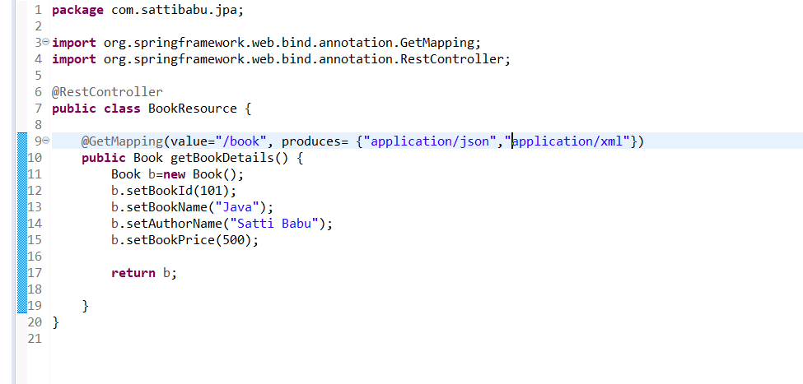

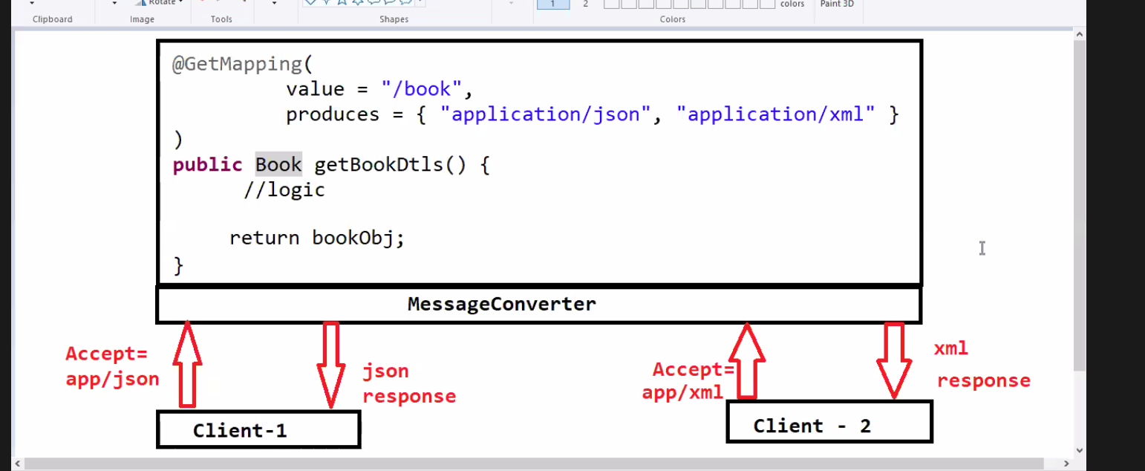

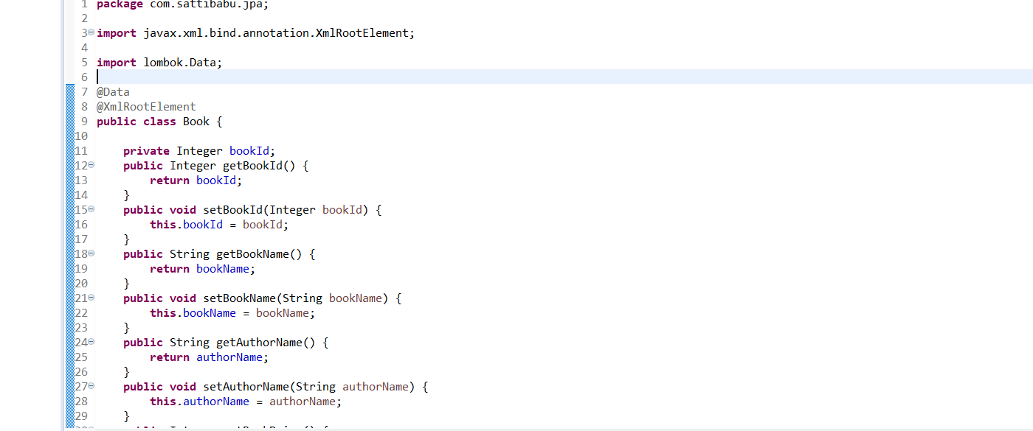

25- Mar-2021—No class

**26-Mar-2021**

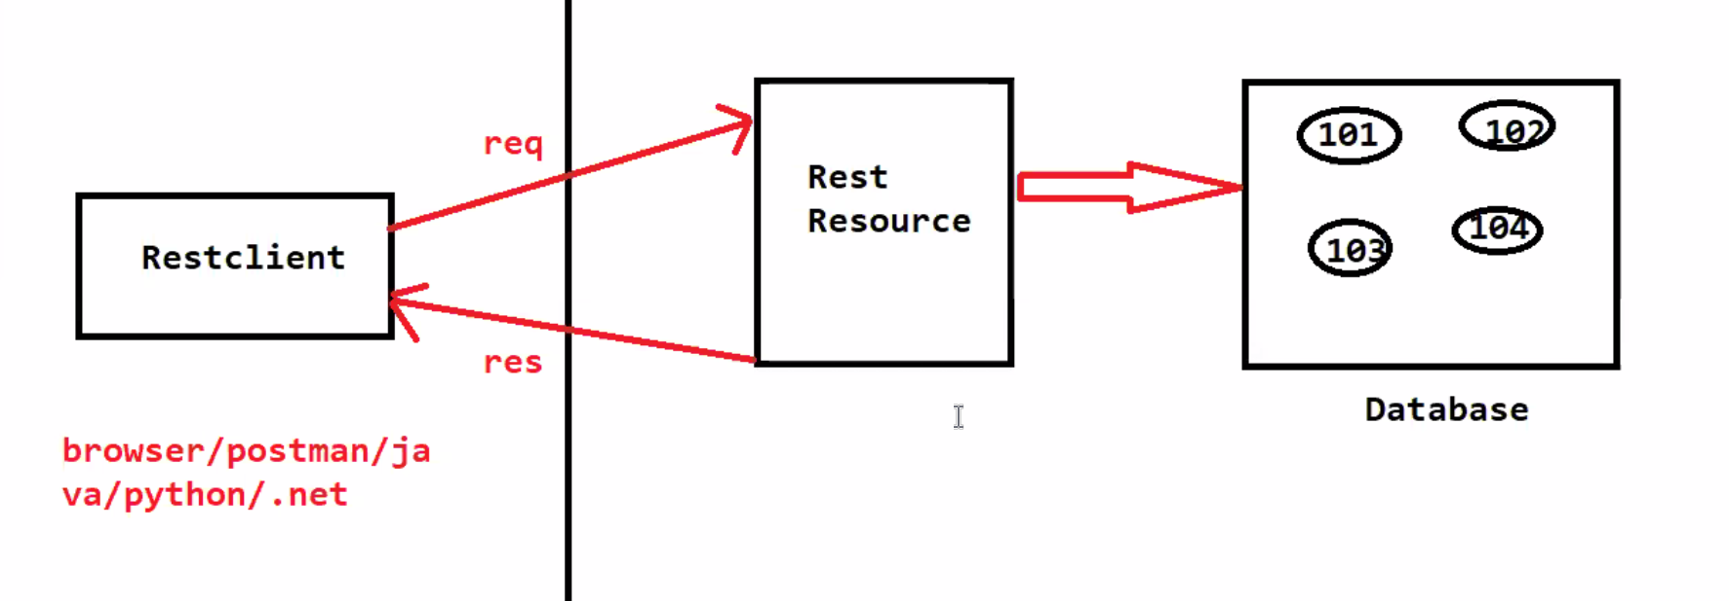

To send the data to Get Request we have two options

1. Query Parameters:- [www.sattibabu./sbms/age=105](http://www.sattibabu./sbms/age=105)
2. Query Parameters are used to send the data in the URL
3. They are represented the in the form of key-value pair
4. Query Parameters should be present in the end of key value pair
5. They start with ?
6. They should be at the end of the URL.

request.getParameter(“Key”);

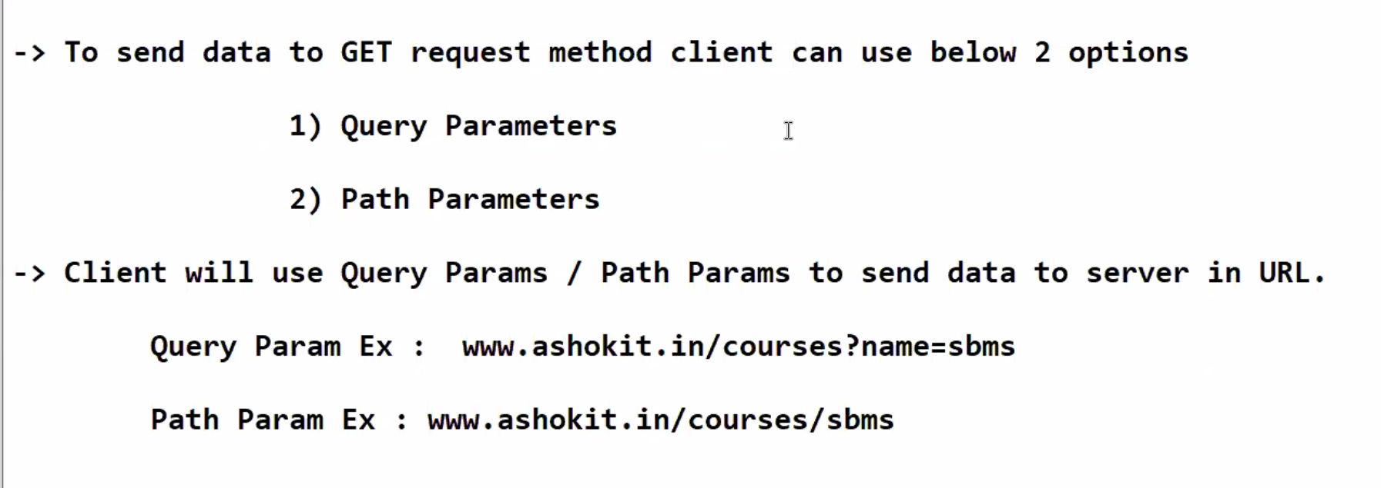

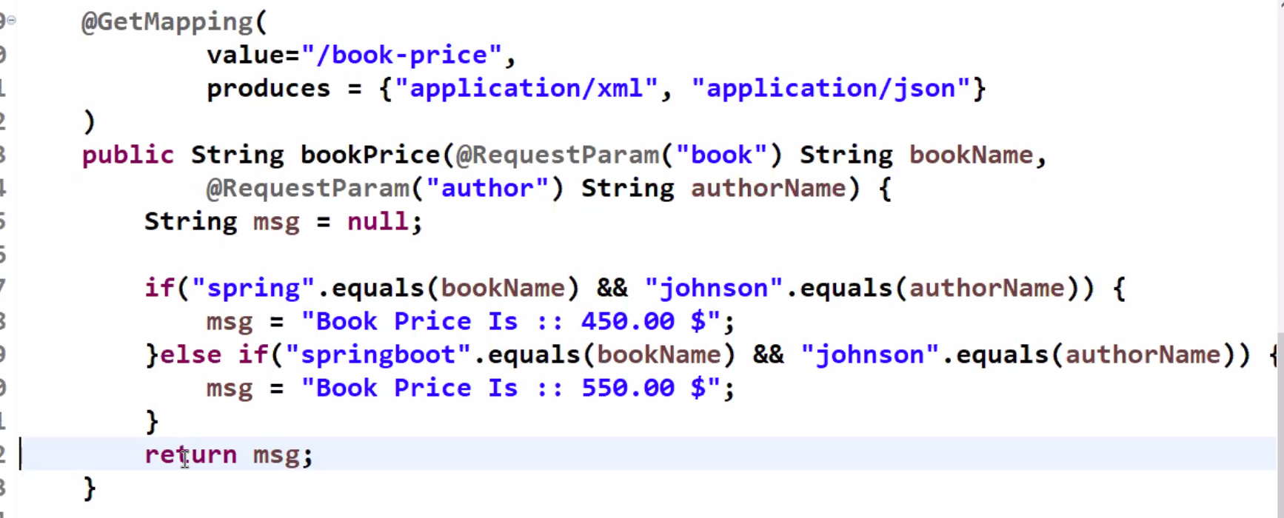

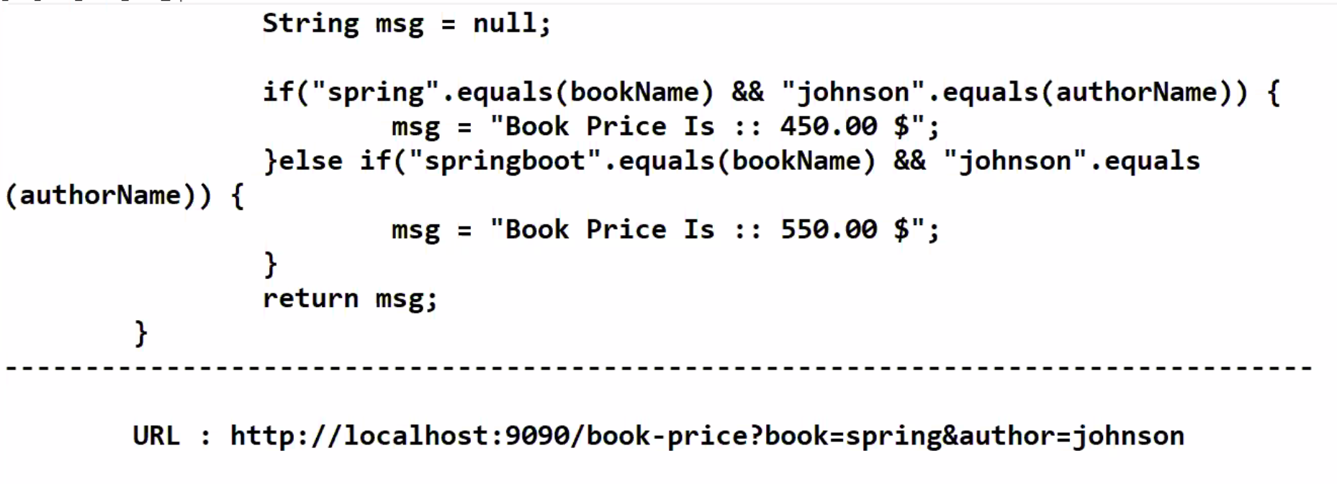

1. PathParameters. :- [www.sattibabu/sbms](http://www.sattibabu/sbms).

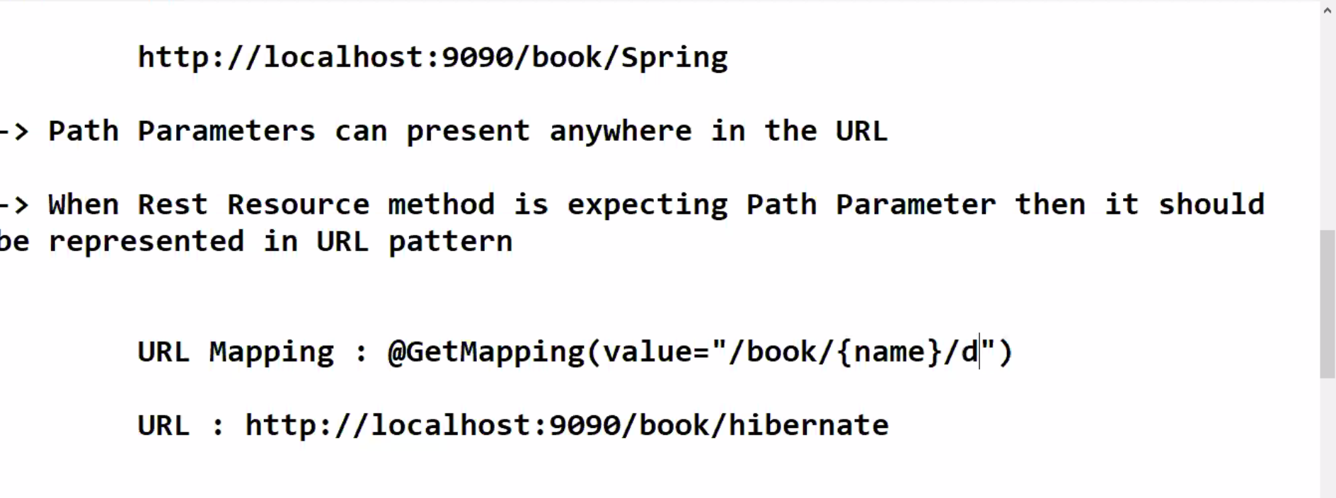

Query paramerts are used to read the values @QueryParam annotion

To read the values using path parameters we will use @PathParam

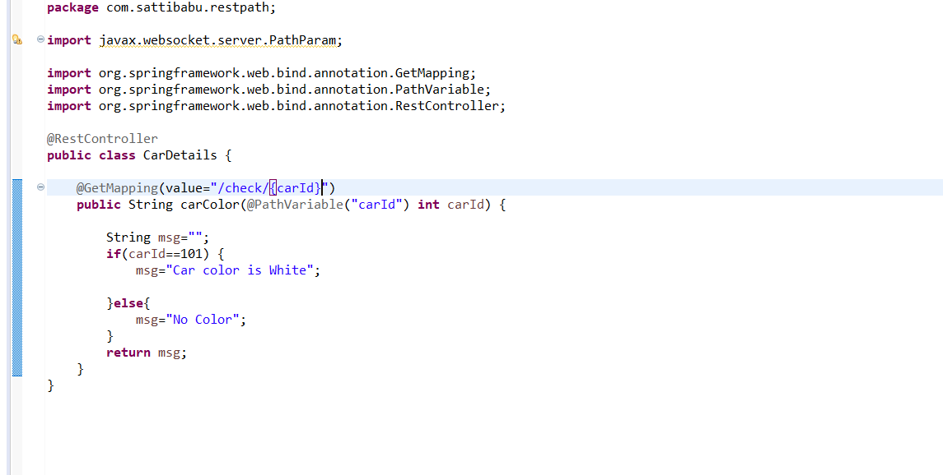

**Drawbacks of Path Param and Query Param**

Length constraint -1024 characters

Cant send any binary data like videos

Security Problems may arises because data will be displayed in the URL.

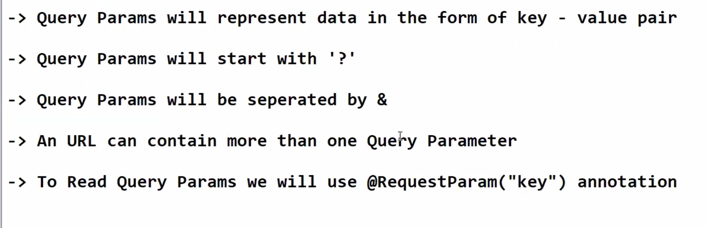

**Http Request and Http Response:-**

Client Server Architecture:-

Client will send a request and response will be send by Server.

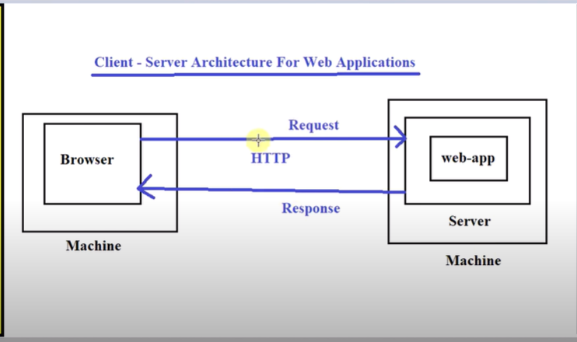

Http stands for HyperTextTransferProtocal. It acts as a mediator between client and server to send request and receive response in Web Application.

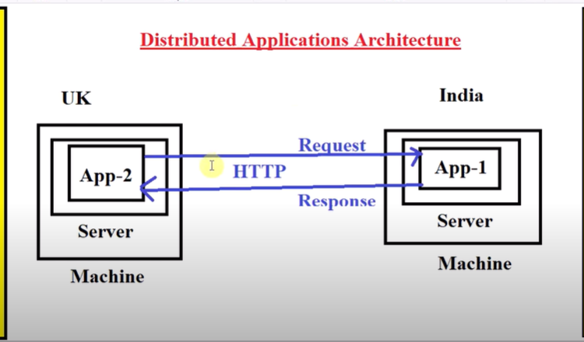

Http Protocol is divided into 2 parts

1. Http Request
2. Http Response

Http Request is divided into 5 parts:-

1. Initial Request
2. Host Address
3. Header line
4. Blank line
5. Request Body

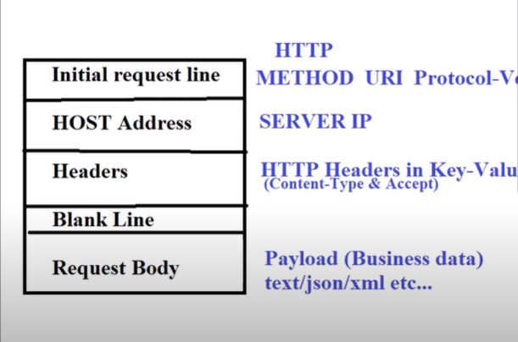

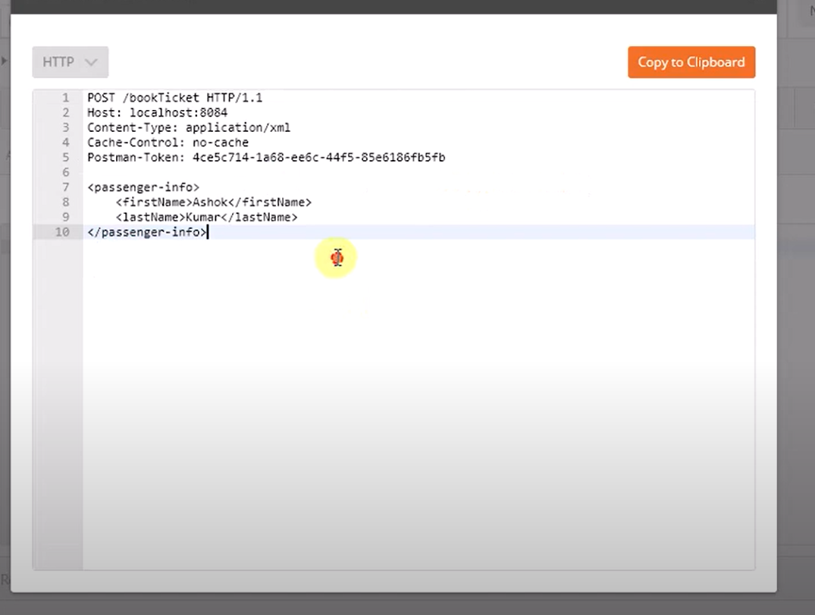

**30-Mar-2021**

To bind the Rest Resource method to post request we will use below method.

@PostMapping is used to

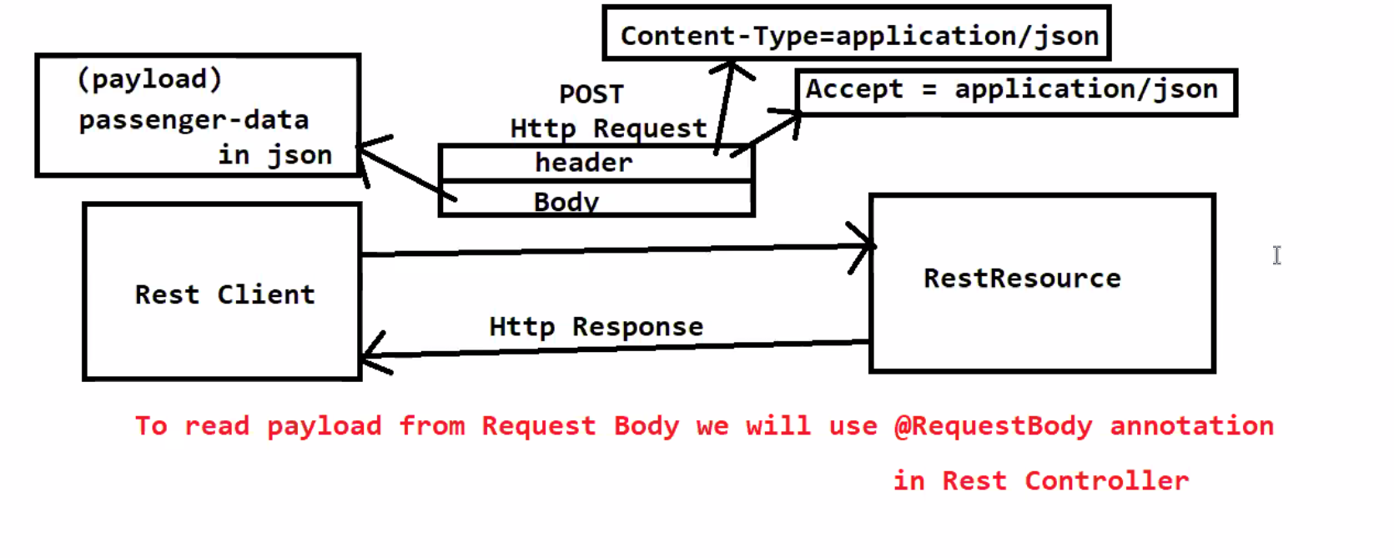

**31-Mar-2021**

Meta Data:- Data about the Data.

@Requestbody Annotation:- To bind the request data to the request is called @RequestBody

Message converter will convert json data to object.

Http Post Request is used to create/insert new record at server.

Post request will contain body section

Client will use Post Request Body section to send the payload to server.

The Data that is sending by client is called Request Payload.

The data that is sending by server is called Response Payload.

**GET vs POST**

Get is used client to receive data from server.

Post is used to receive data from client.

**Methods used in API Development:-**

GET- Client will use to get the data from Server.

POST- Client will use this to send the data to server.

PUT:- Client will use to update the existing record

DELETE:- Delete the record .

**01-Apr-2021**

**Http Status codes and Messages:-**

When client sends request to the server. It will process the request and send the Response back to the client with status code, status message, headers & response body.

Status-code status-msg and Protocol-version

Http status codes are divided into 5 categories

1xx (100-199)--- Information

2xx (200-299)----Success

3xx (300-399)--- Redirectional

4xx (400-499)– Client Error

5xx (500-599)--- Server Error

404 & 500 status codes will see frequently.

404 is request is wrong

500 is server side error.

100—Continue—Everything looks okay

101 – Switching upgrade. It is switching to the Server

102 – Processing . Server is processing the client Request.

103 – Early hints Intended to be used with the link Header, letting the user agent start the pre loading the resoueces while response comes back

**Successful responses:-**

200 --- OK The request has succeeded.

201 – The request has **succeeded and a new resource has been created as a result**. This is typically the response sent after post request.

202 – **The request has been received but not yet acted upon.** Means Might some batch process. Or something scheduled later.

203 – **Non-Authoritative information**. This response code represents the meta information is not exactly same as in the response server.

204 –There is **no content** so send for this request.

205 --- Reset Content Tells the user agent to reset the document which sent this request

206 – Partial Conent.

**Redirection Messages:-**

300 – Multiple Choice – The request has more than one possible response. (There is no standardized way of choosing one of the responses, but HTML links to the possibilities are recommended so the user can pick.)

301 – Moved permanently The URL of the requested resource is moved permanently. The new URL is given in the response.

302 – The URI of the requested resource has been changes temporarily.

[**303 See Other**](https://developer.mozilla.org/en-US/docs/Web/HTTP/Status/303)

The server sent this response to direct the client to get the requested resource at another URI with a GET request.

[**304 Not Modified**](https://developer.mozilla.org/en-US/docs/Web/HTTP/Status/304)

This is used for caching purposes. It tells the client that the response has not been modified, so the client can continue to use the same cached version of the response.

305 – Use proxy

307 – Temporarily Redirect

308 – Permanent Redirect

**Client error Response:-**

400 --- Bad Request – The request could not understand by server due to invalid syntax.

401 – Unauthorized -- That is, the client must authenticate itself to get the requested response

402 --- Payment required

403 – Forbidden -- The client does not have access rights to the content

404 – Not found

405 -Method Not Allowed

406—Not Acceptable

407 – Proxy Authentication required

408 -- Request time out.

[**413 Payload Too Large**](https://developer.mozilla.org/en-US/docs/Web/HTTP/Status/413)

Request entity is larger than limits defined by server; the server might close the connection or return an Retry-After header field.

[**414 URI Too Long**](https://developer.mozilla.org/en-US/docs/Web/HTTP/Status/414)

The URI requested by the client is longer than the server is willing to interpret.

[**415 Unsupported Media Type**](https://developer.mozilla.org/en-US/docs/Web/HTTP/Status/415)

The media format of the requested data is not supported by the server, so the server is rejecting the request.

[**418 I'm a teapot**](https://developer.mozilla.org/en-US/docs/Web/HTTP/Status/418)

The server refuses the attempt to brew coffee with a teapot.

**Server Error Responses:-**

500 -Internal Server Error --- The server has encountered a situation it doesn't know how to handle.

501 – Not Implemented --- The request method is not supported by the server and cannot be handled.

502 – Bad gateway – Invalid Response.

503 --- Service Unavailble

[**504 Gateway Timeout**](https://developer.mozilla.org/en-US/docs/Web/HTTP/Status/504)

This error response is given when the server is acting as a gateway and cannot get a response in time.

505 –HTTP version is not supported

511 – Network Authentication Required.

**05-Apr-2021**

Rest Client Introduction.

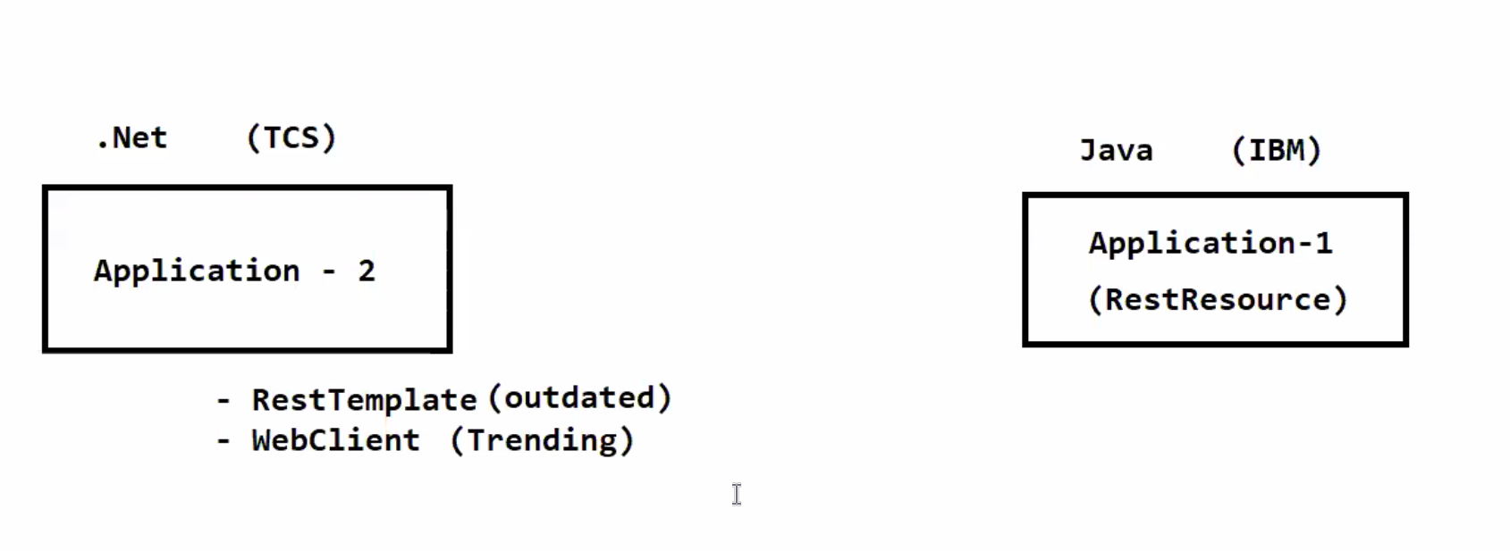

**08-Apr-2021**

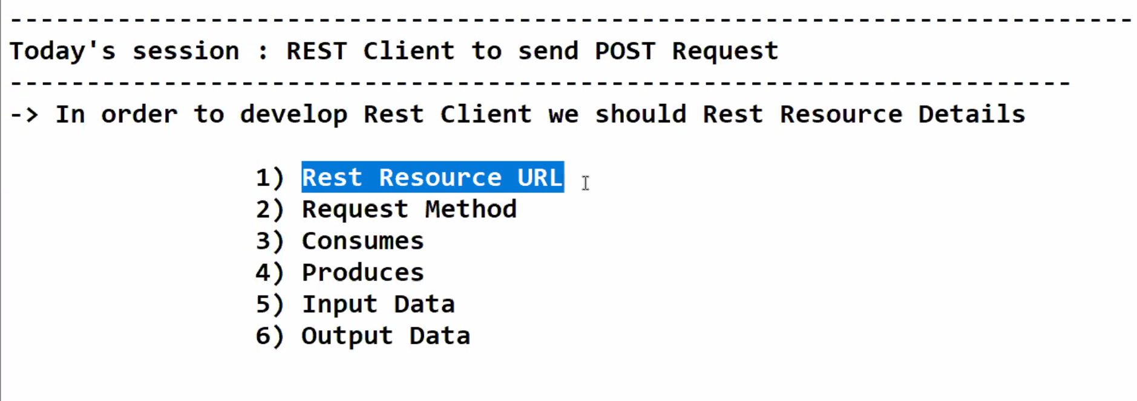

**Rest Client Send POST Request**

In order to develop Rest Client we should Rest Resource Details

* + In order to develop the rest client we should rest Resource Details
    1. Rest Resource URL
    2. Request Method
    3. Consumes
    4. Produces
    5. Input Data
    6. Output Data

We will get the API Data by using Swagger or Document.

Resource <URL:-> <http://localhost:9090/enrolment>

Request method:POST

Consumes:- application/json

Produces:- text/plain

Input Data Format:-

{

“dob”:-

}

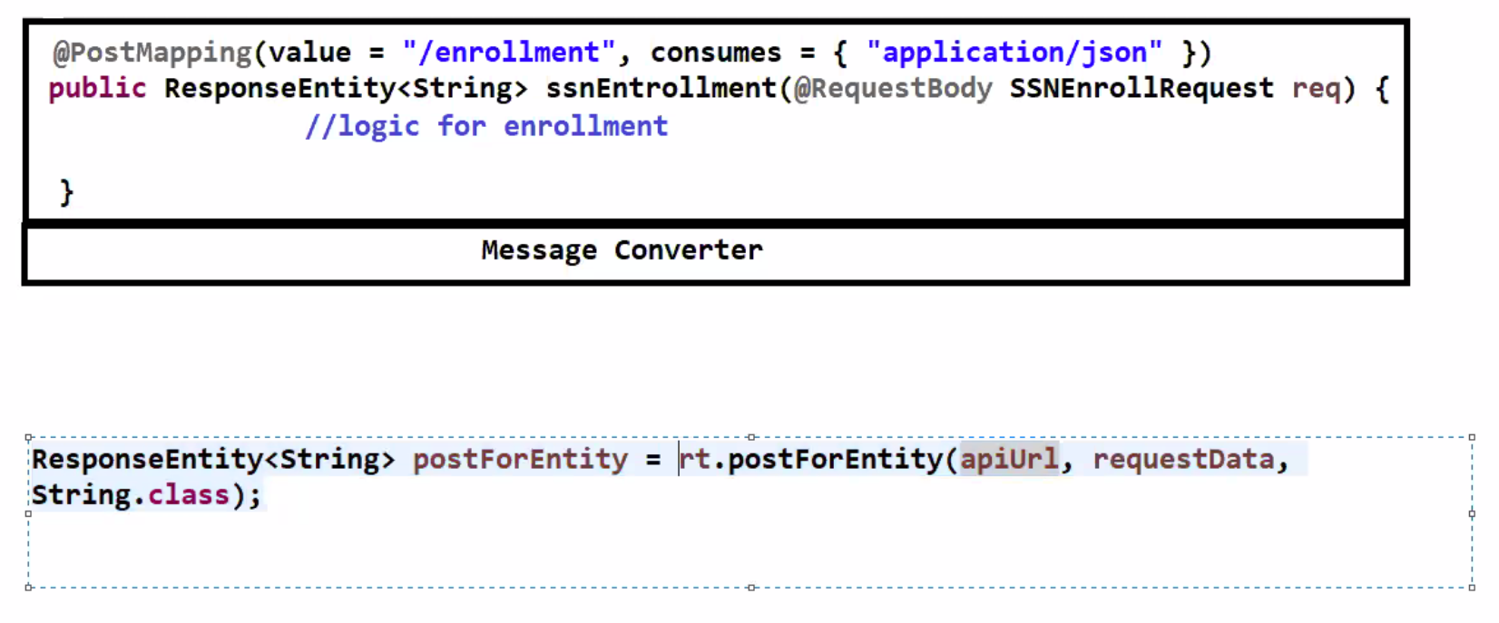

**9-Apr-2021**

**Develop a RestClient to book the Train Ticket.**

API <URL:-> http://localhost:9090/book-ticket

Resource Method:- POST

Consumes Format:- application/json

Produces Format:- application/json

Sample Input:-

Sample Output:-

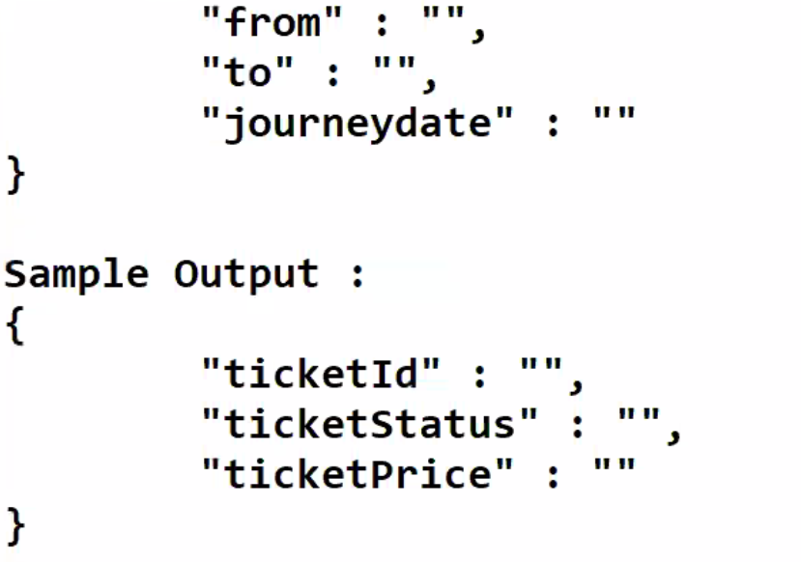

We need to createa binding class.

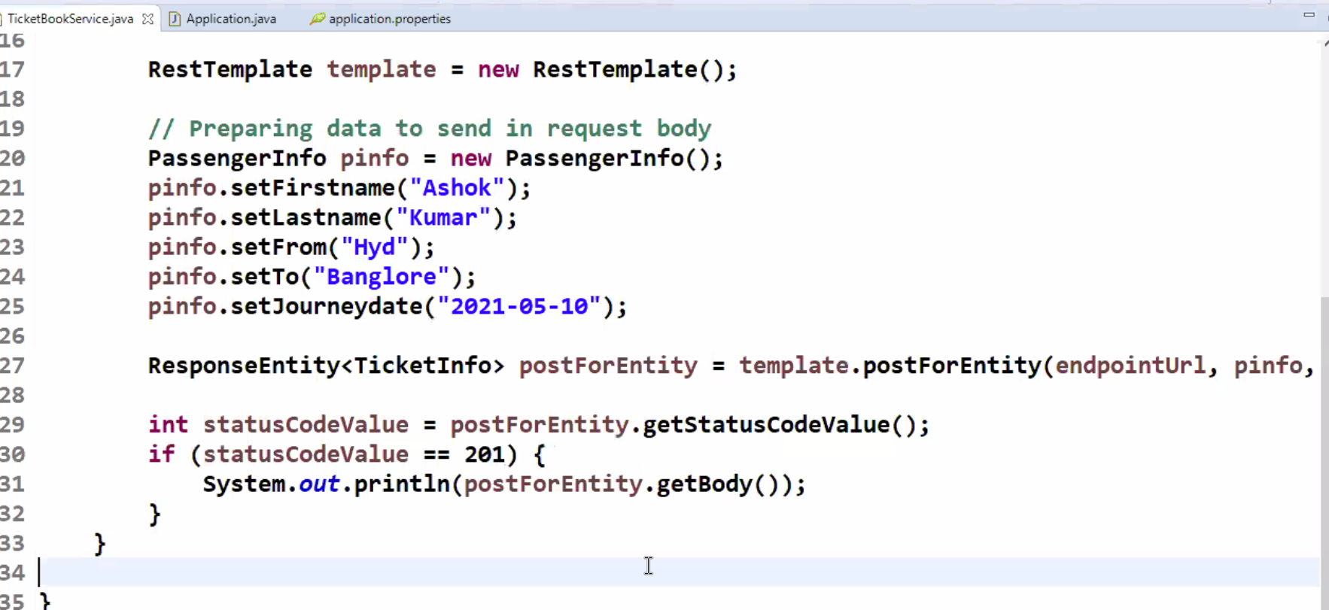

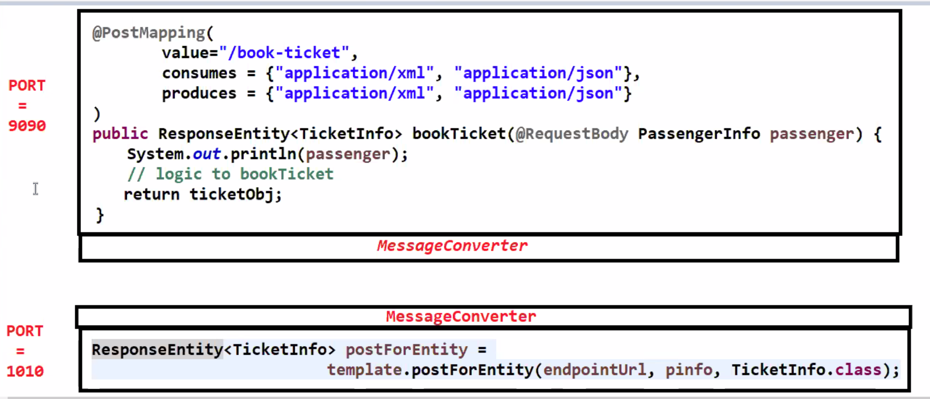

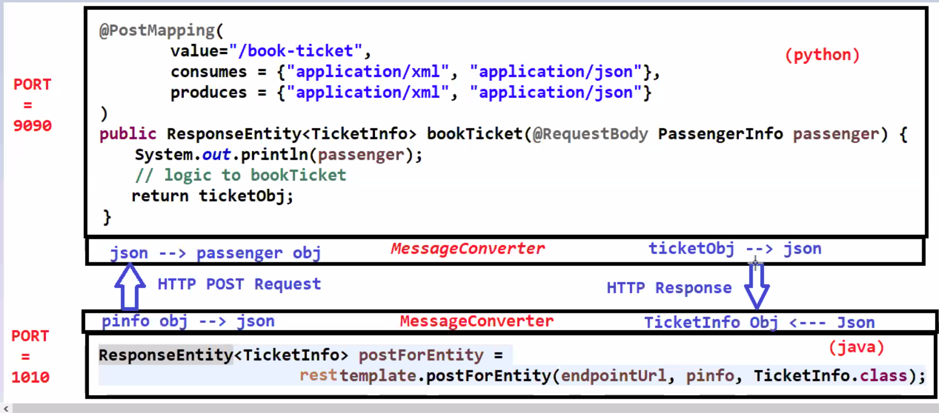

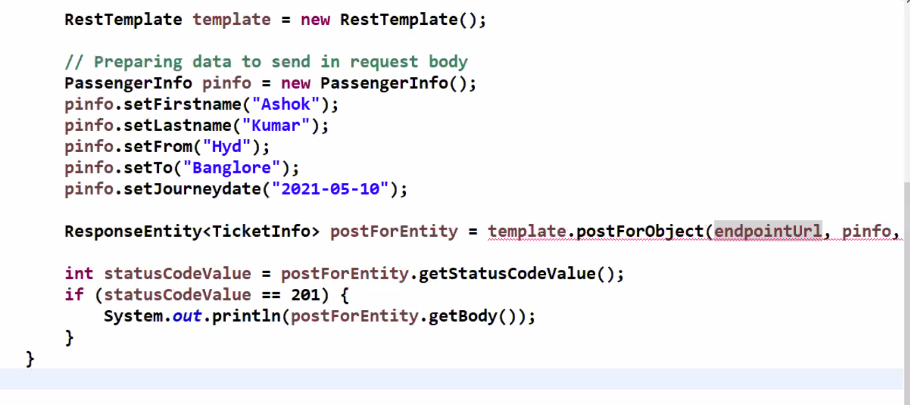

RestController will be used at Resource side

And RestClient or webclient will be used at Client side.

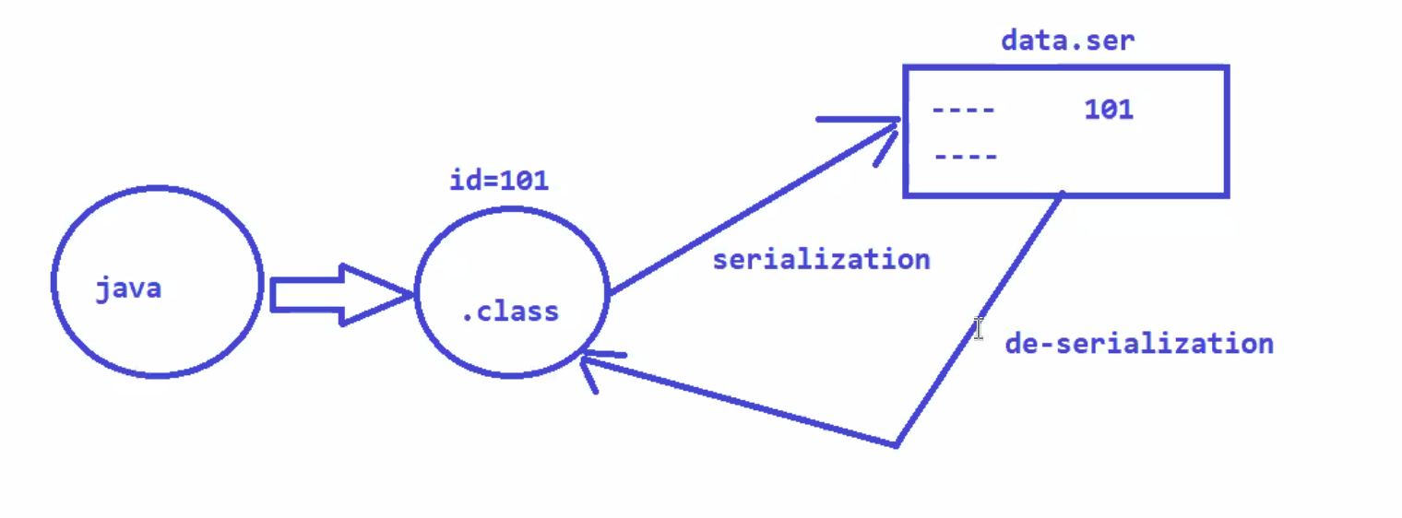

**14-Apr-2021**

**Microservices:-**

**Monolith Application:-**

If we develop all the functionalities as a single application that is called Monolithic Application.

**Monolithic Architecture based Application**

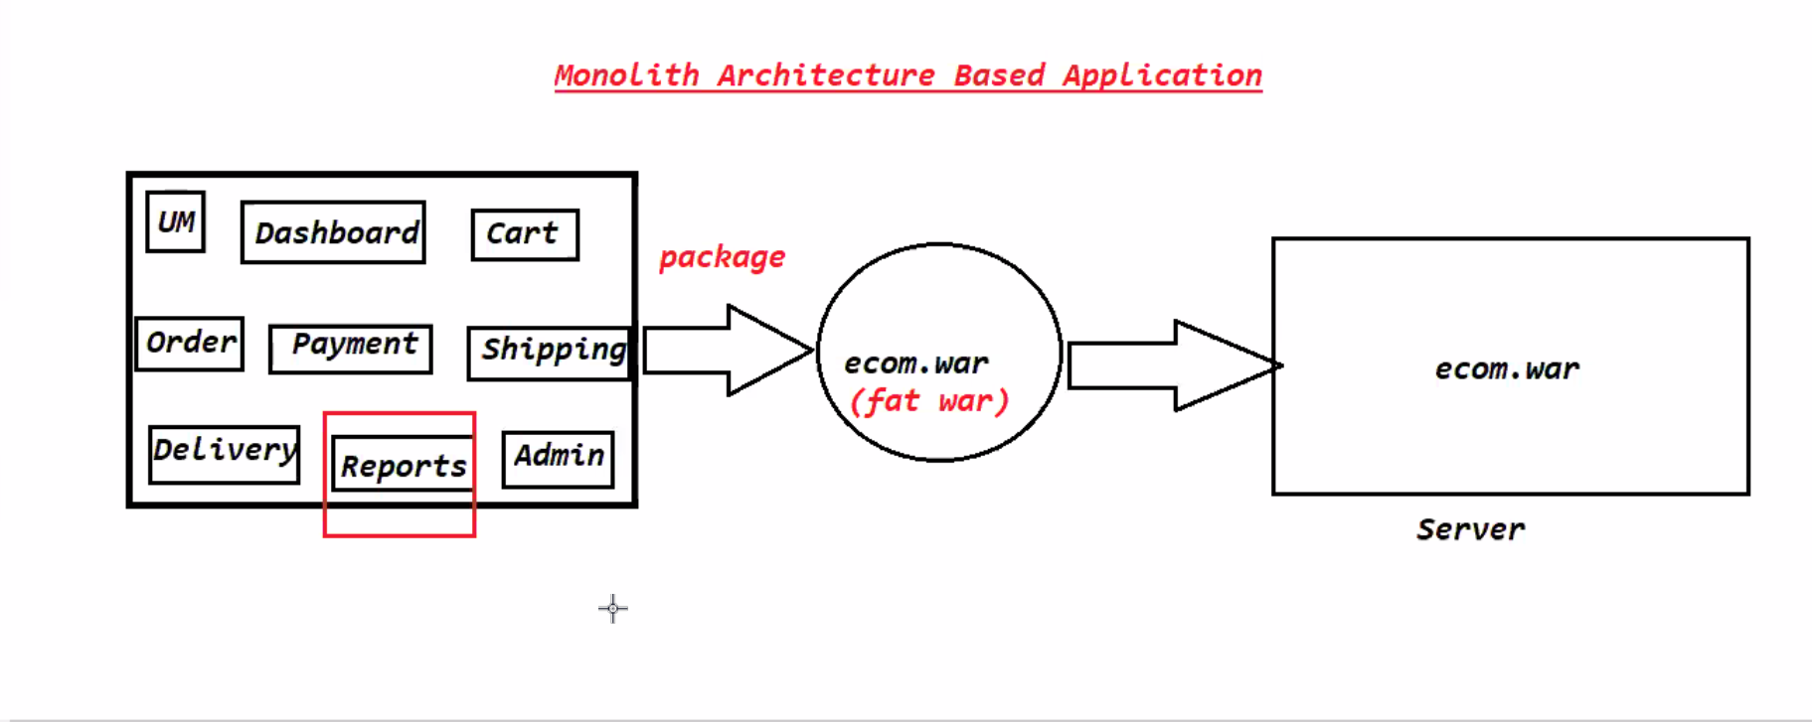

**Disadvantages of Monolithic Application:-**

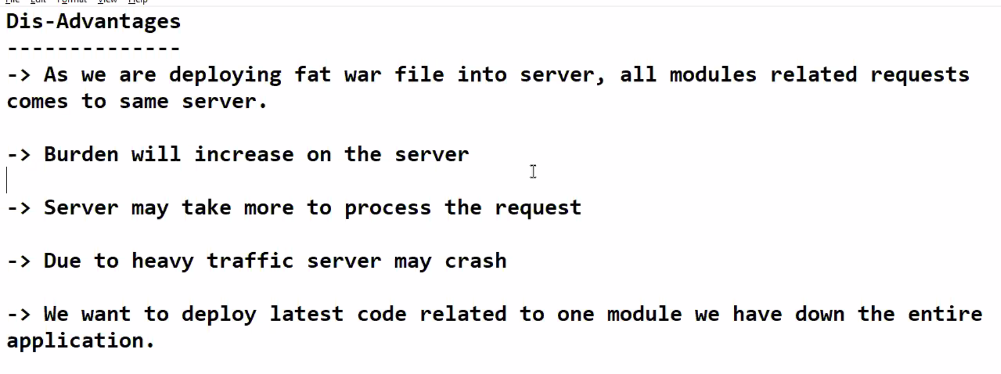

Burden will increase on the Server

Server may take more time to process the request

Due to heavy traffic server may crash

We have to down the entire application for change in one module.

To overcome the drawbacks of Monolith Architecture people are following Microservices architecture to develop the projects.

* Microservices is not a technology
* Microservices is not a framework
* Microservices is not a API.
* Microservices is an architectural design pattern which suggesting us to develop our Application with easy maintenance.
* It is not only for java application. It is the universal solution.
* It is suggesting us to follow divide and conquer principle.

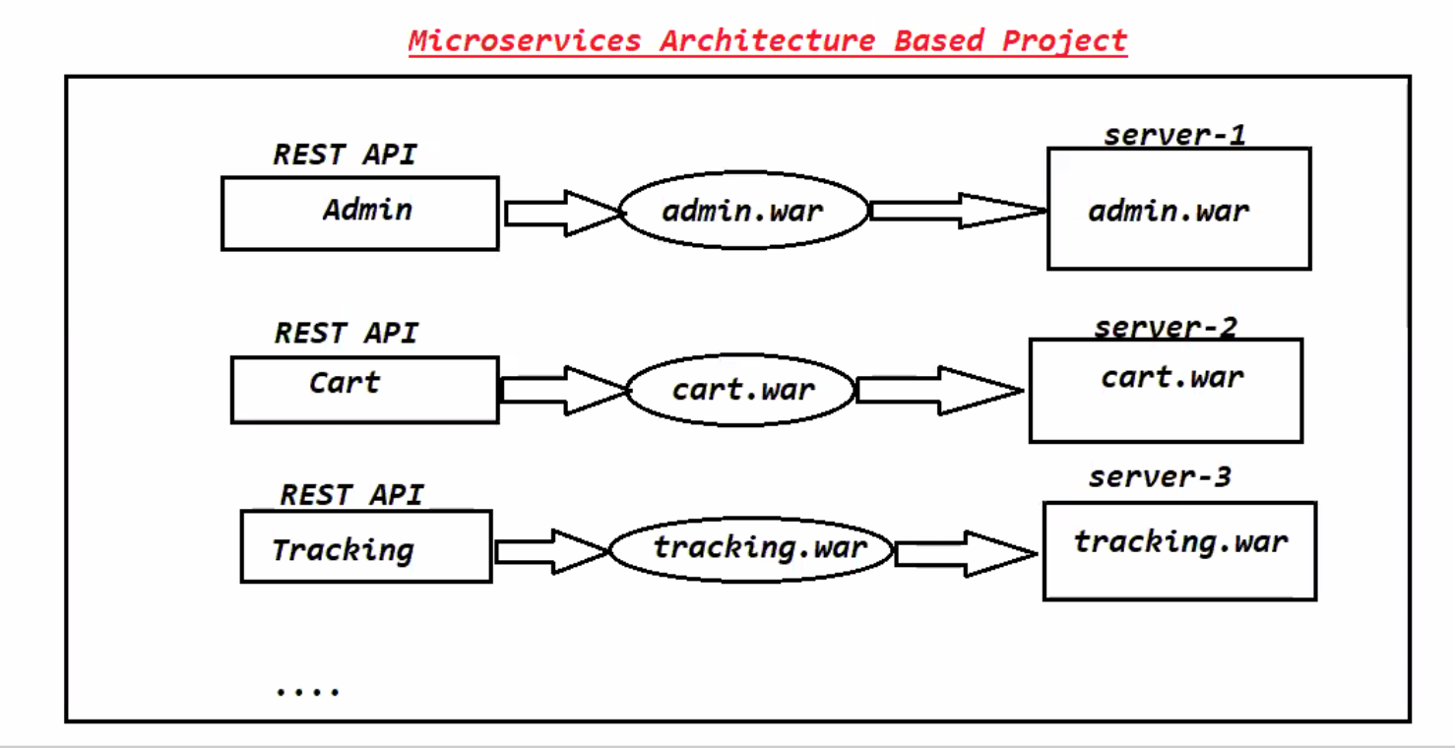

It suggests that don’t develop a 100 functionalities into single functionality.

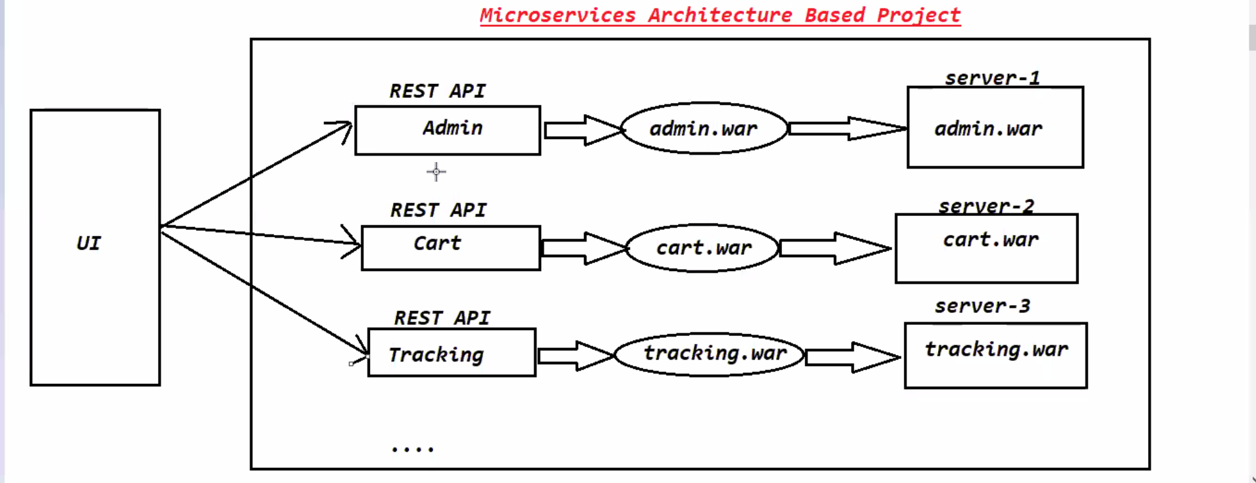

**16-Apr-2021**

Challenges with Microservices Architecture:-

1.Bounded Context

2. Configuration

3. Visibility

4. Pack of Cards:- If one Rest API crashed cant talk to another REST api.

**Advantages of Microservices:-**

1. Fast Releases:- No need to wait for whole project. I can release one Rest API to production.
2. Easy Deployment:-